S. Rushi Keshava Reddy
192472355

CSA-0606- DESIGN AND ANALYSIS OF ALGORITHMS
CHAPTER 1 - LIST OF EXPERIMENTS

Experiment 1: Linear Search (Iterative)
• Objective: To analyze time complexity of linear search.
Problem Statement: Write a Python program to search for a key in an array using linear search.
• Sample Input: [10, 25, 30, 45, 50], Key = 30
• Sample Output: Key found at index 2
• Complexity: Q: O(1), O: O(n), 0: 0(n)
• Explanation: Demonstrates sequential scanning and inefficiency for large inputs.
CODE:

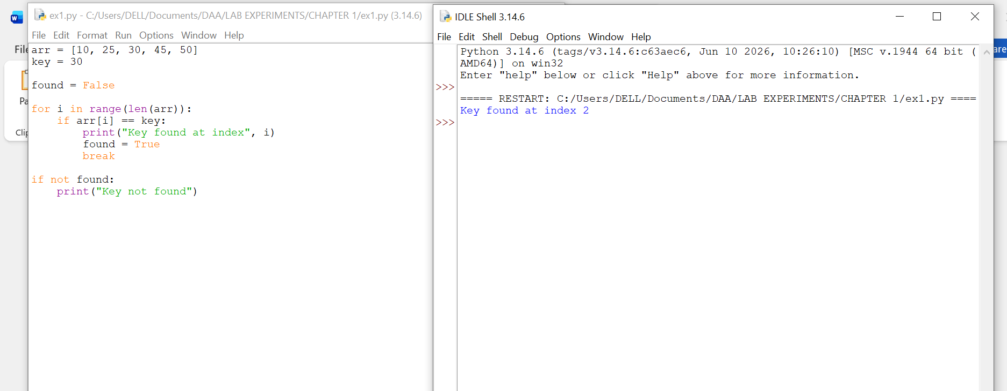

Experiment 2: Binary Search (Recursive)
• Objective: To compare recursive binary search complexity.
Problem Statement: Implement recursive binary search in Python.
• Sample Input: [5, 10, 15, 20, 25], Key = 20
• Sample Output: Key found at index 3
• Complexity: Q: O(1), O: O(logn), O: O(logn)
• Explanation: Shows divide-and-conquer and logarithmic efficiency.

CODE:

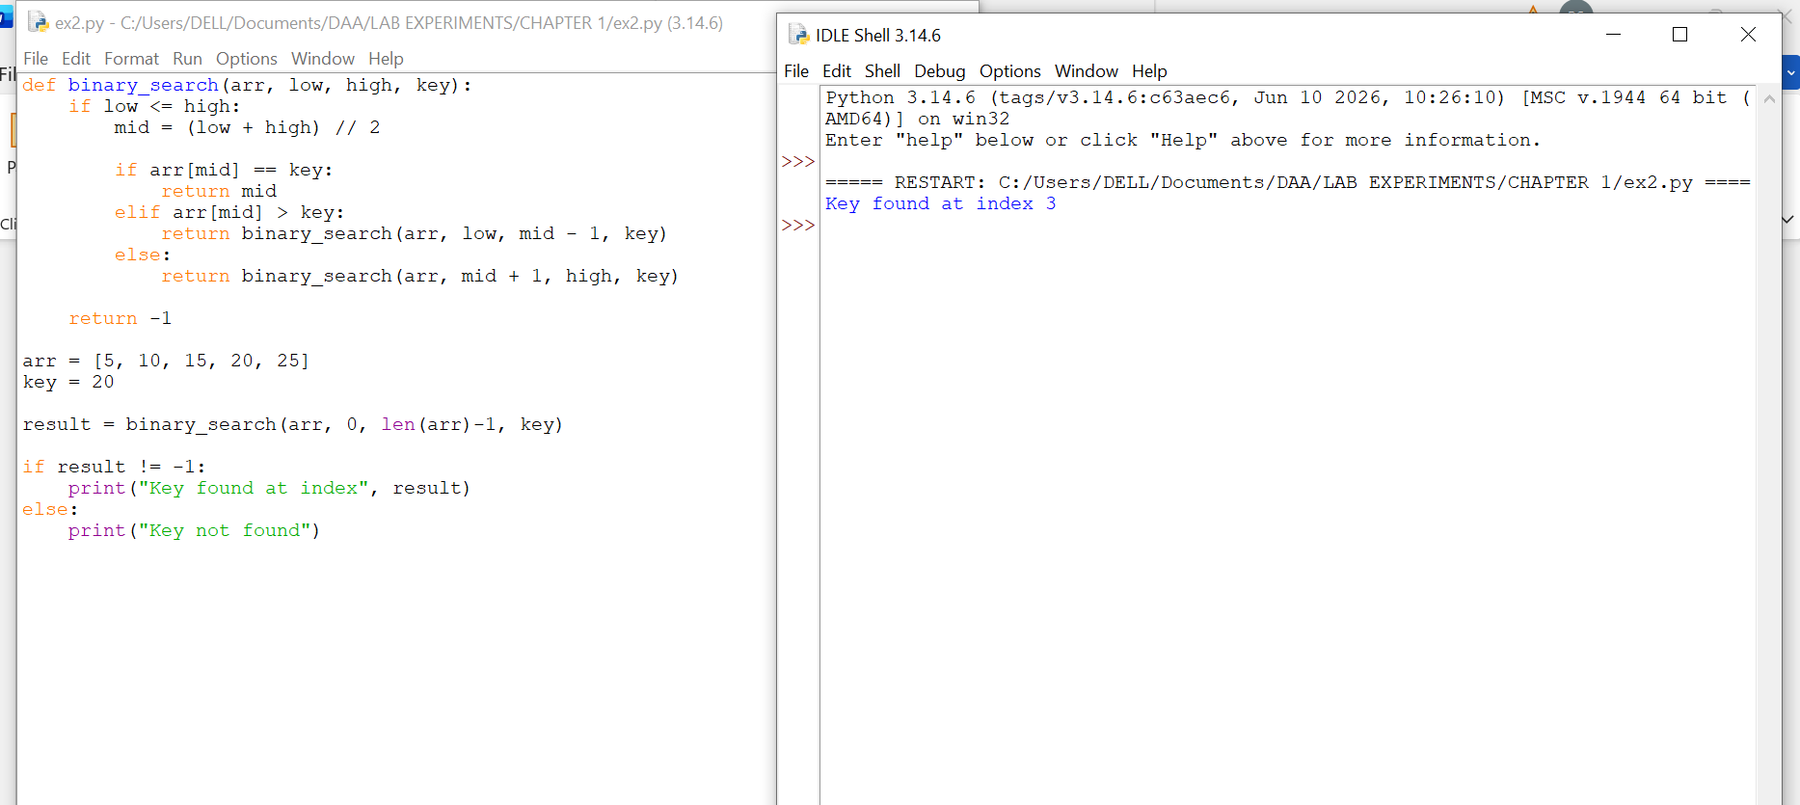

Experiment 3: Factorial (Iterative vs Recursive)
• Objective: To compare iterative and recursive factorial computation. Problem Statement: Write programs to compute factorial using both methods.
• Sample Input: n = 5
• Sample Output: 120
• Complexity: Both O(n)
• Explanation: Highlights recursion depth vs iterative loops

CODE:
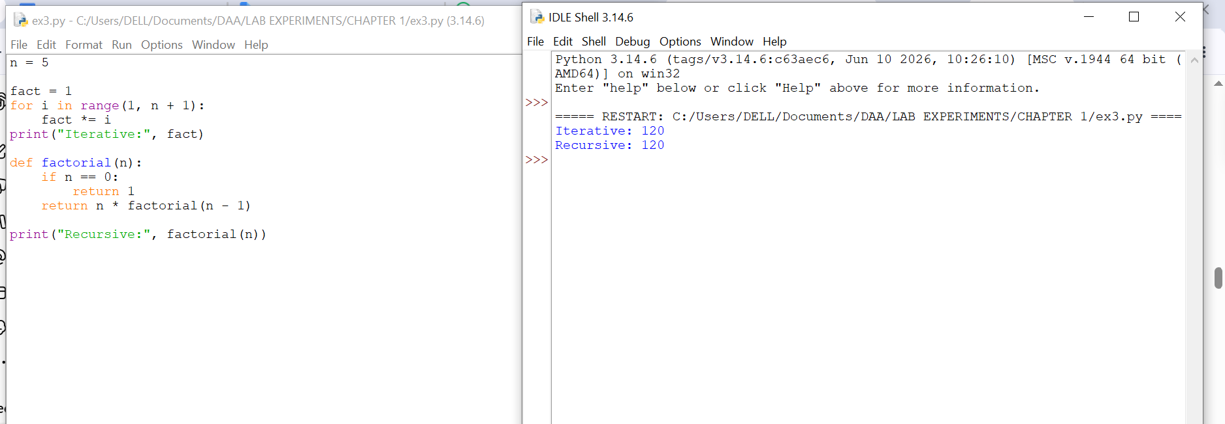

Experiment 4: Fibonacci Series
• Objective: To analyze recursive vs iterative Fibonacci generation.
• Problem Statement: Generate first n Fibonacci numbers.
• Sample Input: n = 6
• Sample Output: [0, 1, 1, 2, 3, 5]
• Complexity: Iterative O(n), Recursive naïve O(2n), Recursive with
memoization O(n)
• Explanation: Illustrates exponential recursion vs efficient iteration.
CODE:
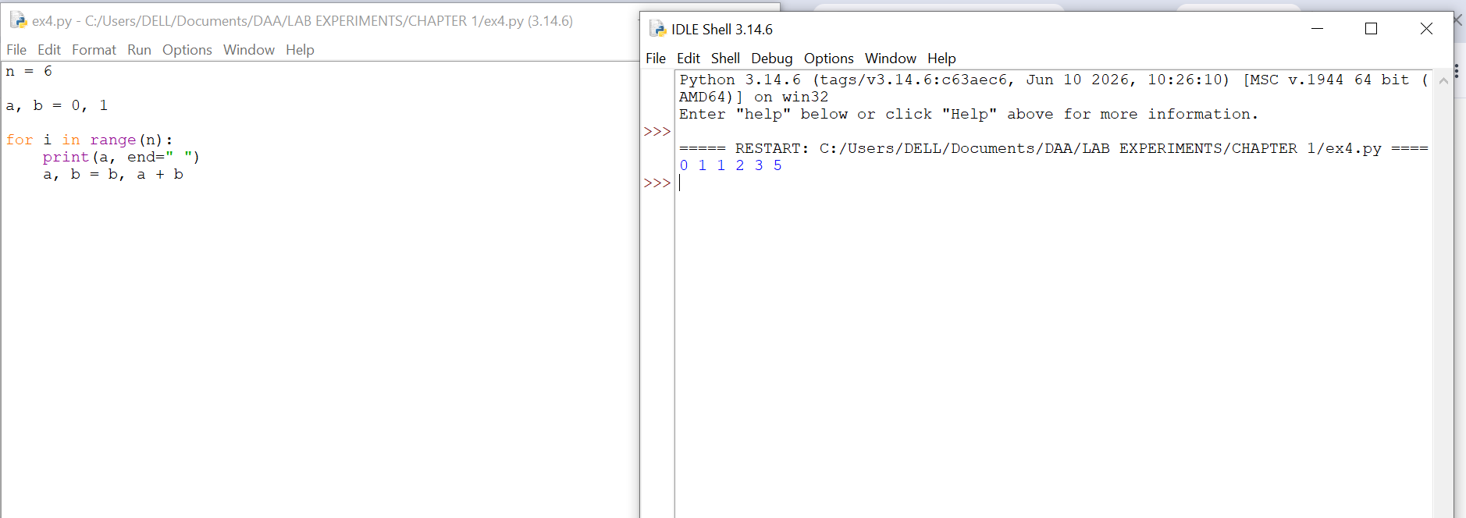

Experiment 5: Matrix Multiplication
• Objective: To analyze nested loop complexity.
Problem Statement: Multiply two matrices using loops.
• Sample Input: A= [[1, 2], [3,4]], B=[[5, 6], [7, 8]]
• Sample Output: [[19, 22], [43, 50]]
• Complexity: O(n3)
• Explanation: Shows cubic growth due to nested loops.

CODE:
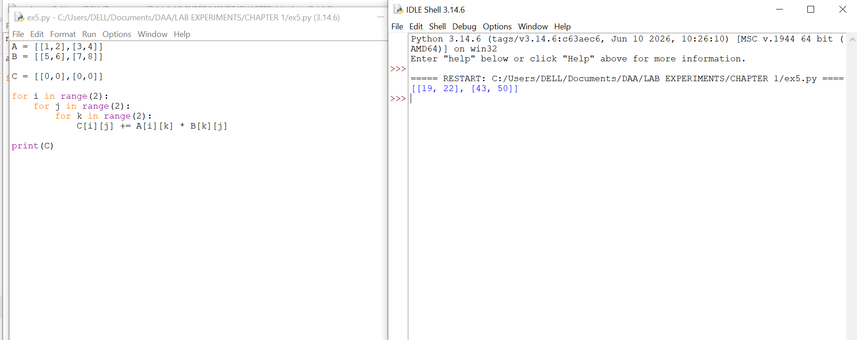

Experiment 6: Merge Sort
• Objective: To analyze divide-and-conquer sorting.
• Problem Statement: Implement merge sort.
• Sample Input: [38, 27, 43, 3, 9, 82, 10]
• Sample Output: [3, 9, 10, 27, 38, 43, 82]
• Complexity: Always O(nlogn)
• Explanation: Demonstrates guaranteed efficiency of divide-and-conquer.

CODE:

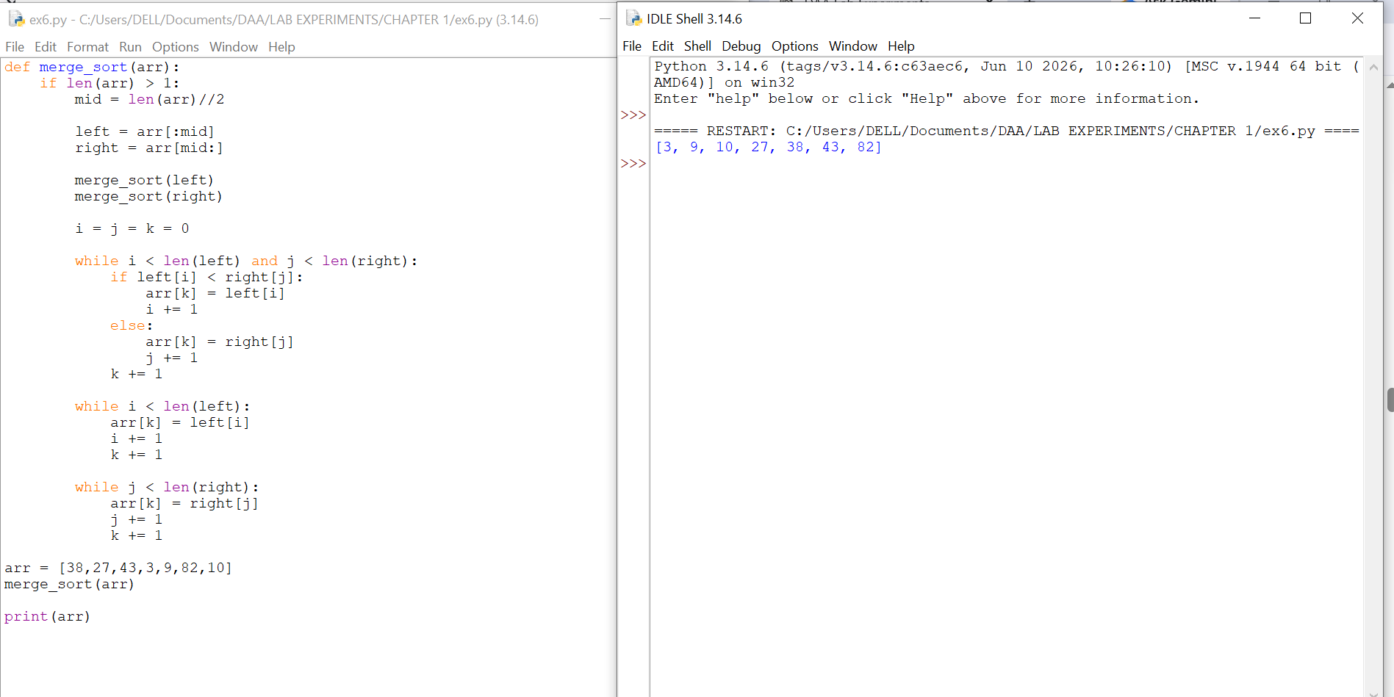

Experiment 7: Quick Sort
• Objective: To analyze recursive quick sort.
• Problem Statement: Implement quick sort.
• Sample Input: [10, 7, 8, 9, 1, 5]
• Sample Output: [1, 5, 7, 8, 9, 10]
• Complexity: Q: O(nlogn), O: O(n2), O: O(nlogn)
• Explanation: Shows how pivot choice affects performance.

CODE:
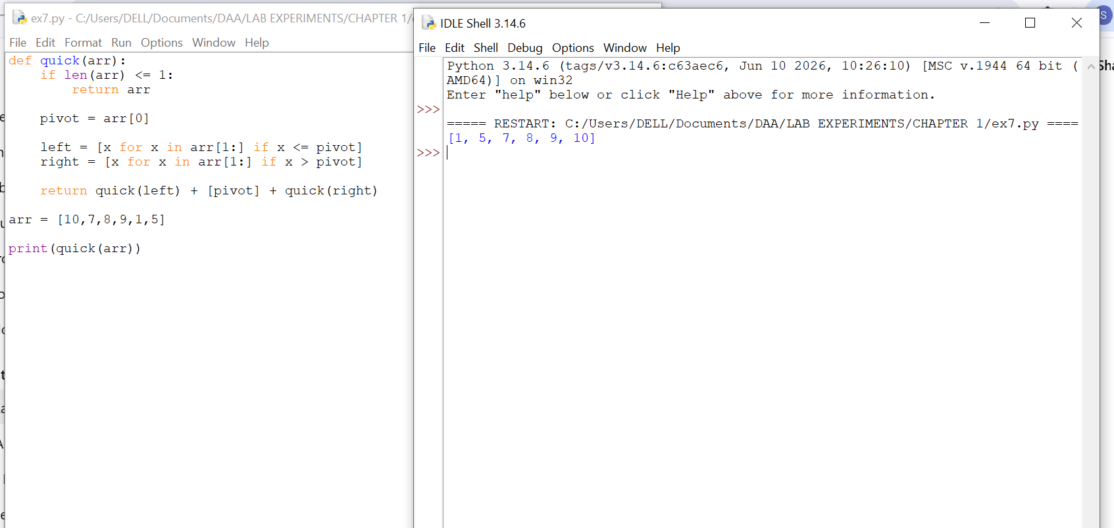

Experiment 8: Tower of Hanoi
• Objective: To analyze exponential recursion.
Problem Statement: Solve Tower of Hanoi for n disks.
• Sample Input: n = 3
• Sample Output: Sequence of moves.
• Complexity: 0(2n)
• Explanation: Illustrates exponential growth in recursive calls.

CODE:
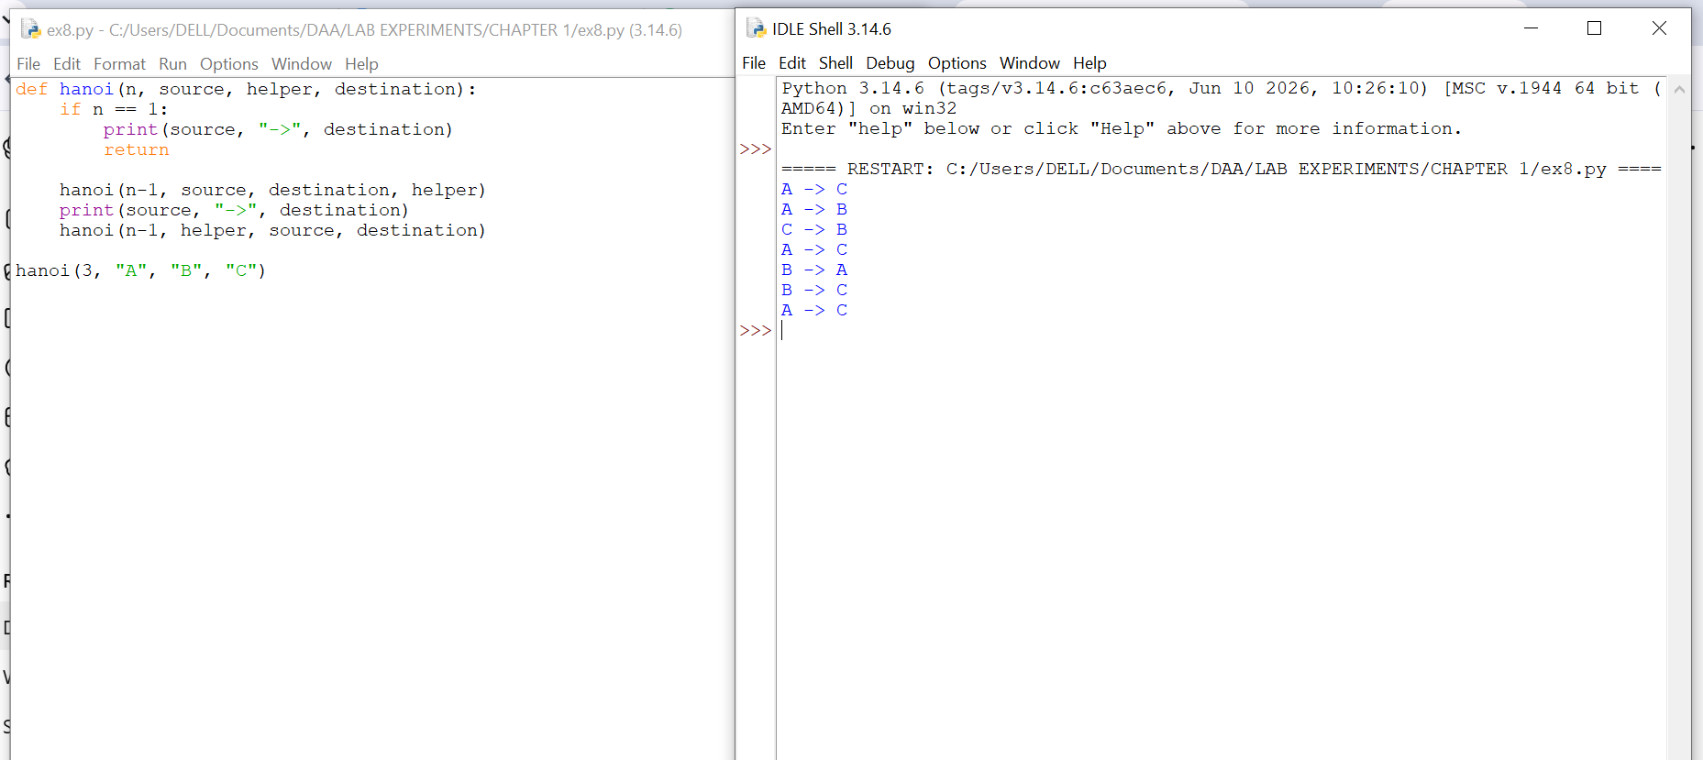

Experiment 9: GCD (Euclidean Algorithm)
• Objective: To analyze recursive GCD.
Problem Statement: Implement Euclidean algorithm.
• Sample Input: a=48, b=18
• Sample Output: 6
• Complexity: O(logn)
• Explanation: Shows efficient recursion with logarithmic complexity.

CODE:
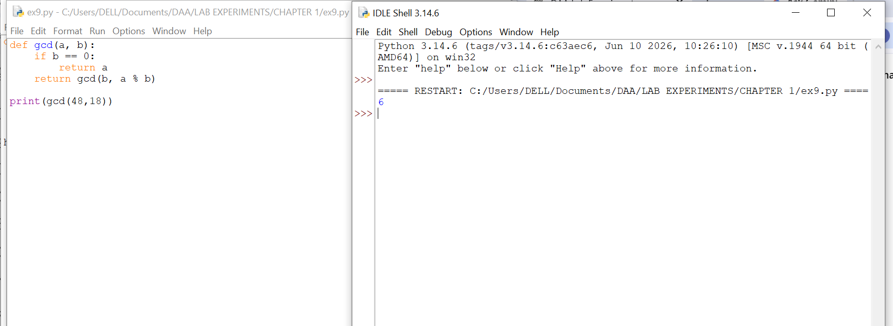

Experiment 10: Insertion Sort
• Objective: To analyze iterative sorting.
• Problem Statement: Implement insertion sort.
• Sample Input: [12, 11, 13, 5, 6]
• Sample Output: [5, 6, 11, 12, 13]
• Complexity: Q: O(n), O: O(n2), O: (n2)
• Explanation: Demonstrates input sensitivity (sorted vs unsorted).
CODE:

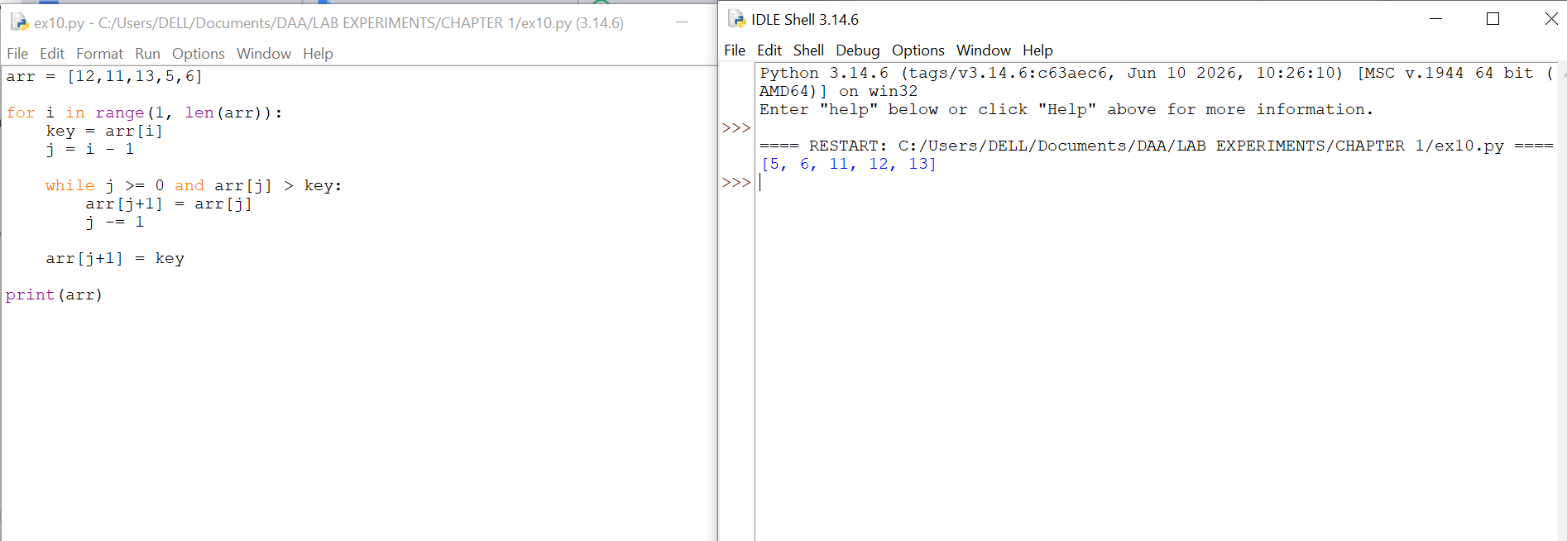

Experiment 11: Heap Sort
• Objective: To analyze heap-based sorting.
Problem Statement: Implement heap sort.
• Sample Input: [4, 10, 3, 5, 1]
• Sample Output: [1, 3, 4, 5, 10]
• Complexity: Always O(nlogn)
• Explanation: Consistent performance using heap structure.

CODE:

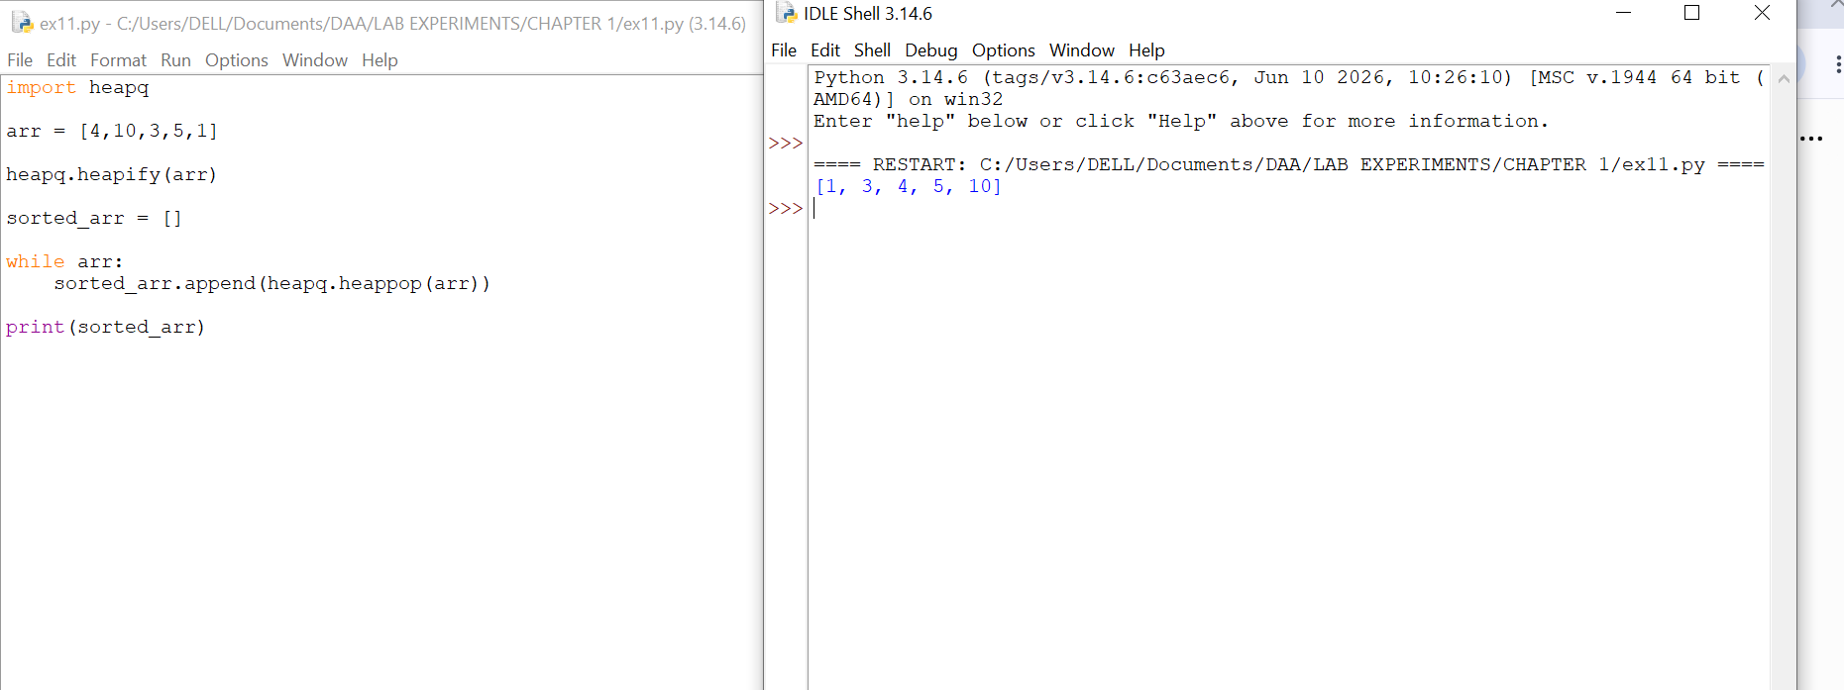

Experiment 12: Counting Inversions
• Objective: To analyze modified merge sort.
• Problem Statement: Count inversions in an array.
• Sample Input: [2, 4, 1, 3, 5]
• Sample Output: 3
• Complexity: O(nlogn)
• Explanation: Shows divide-and-conquer applied beyond sorting.
CODE:

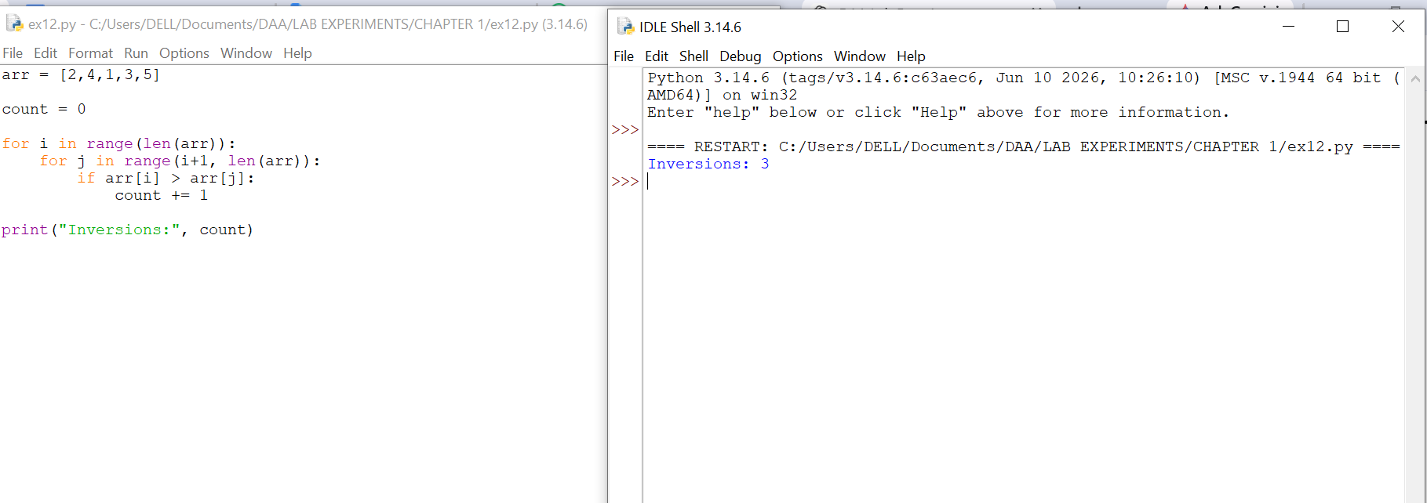

Experiment 13: Maximum Subarray Sum
• Objective: To compare Kadane's vs divide-and-conquer. Problem Statement: Find maximum subarray sum.
• Sample Input: [-2, -3, 4, -1, -2, 1, 5, -3]
• Sample Output: 7
• Complexity: Kadane's O(n), Divide & Conquer O(nlogn)
• Explanation: Highlights efficiency differences between approaches.
CODE:
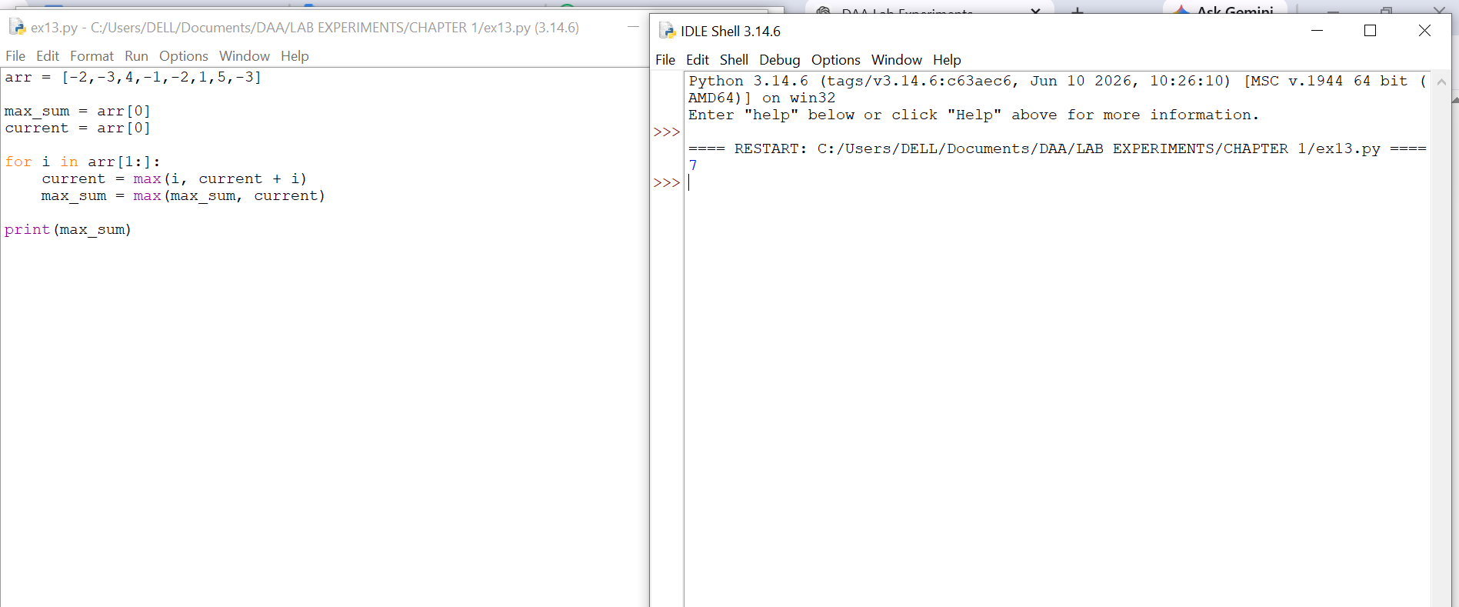
Experiment 14: Exponentiation
• Objective: To compare iterative vs recursive fast power.
Problem Statement: Compute xn.
• Sample Input: x=2, n=10
• Sample Output: 1024
• Complexity: Iterative O(n), Recursive fast power O(logn)
• Explanation: Shows how recursion reduces complexity.
CODE:

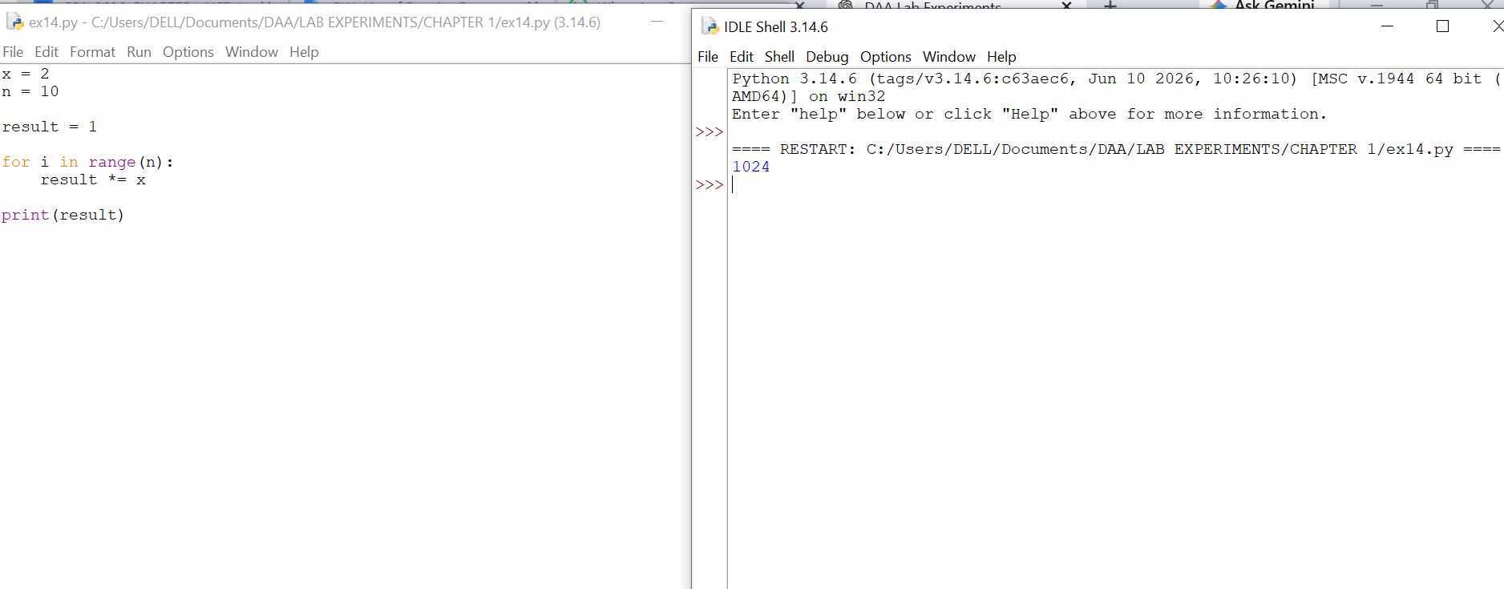

Experiment 15: Closest Pair of Points
• Objective: To analyze brute force vs divide-and-conquer.
• Problem Statement: Find closest pair of points in 2D.
• Sample Input: [(1,2), (4,5), (7,8), (3,1)]
• Sample Output: Closest pair (1,2)-(3, 1), Distance = √5
Complexity: Brute force O(n2), Optimized O(nlogn)
Explanation: Demonstrates quadratic complexity and motivates optimization.

CODE:

